### *This *document works when imported and copied from Google docs.*

### **Copy everything (including images) below and paste into Medium.**

### **Minato Is Now KYC Approved by Assure DeFi.**

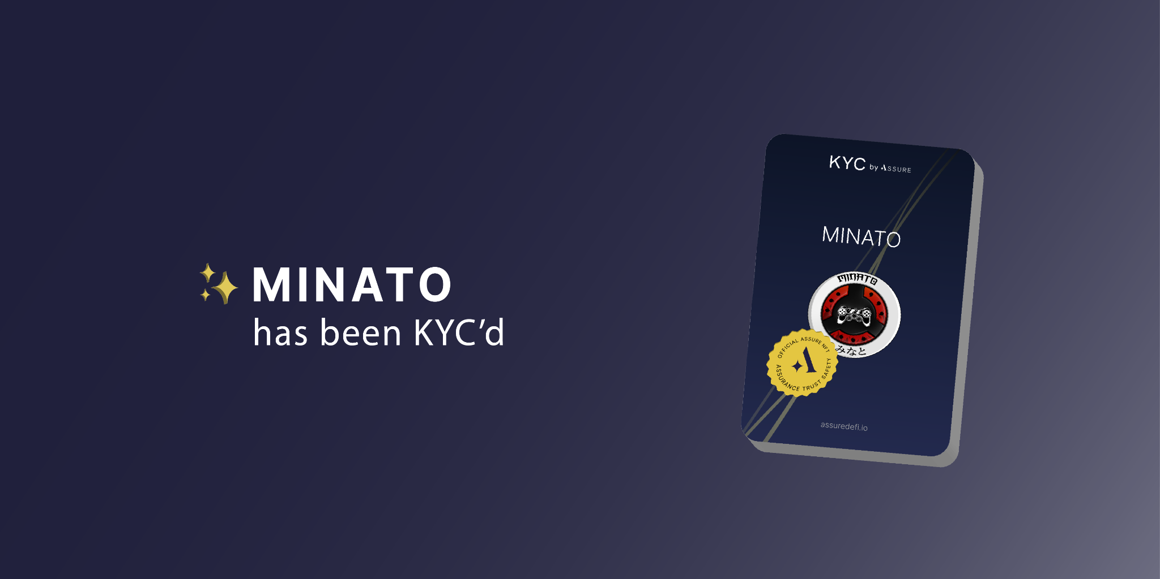

We are excited to announce that **Minato** has gone through the KYC identity verification process and has now been APPROVED.

You can view our compliance NFT here: **https://www.assuredefi.io/projects/minato/**

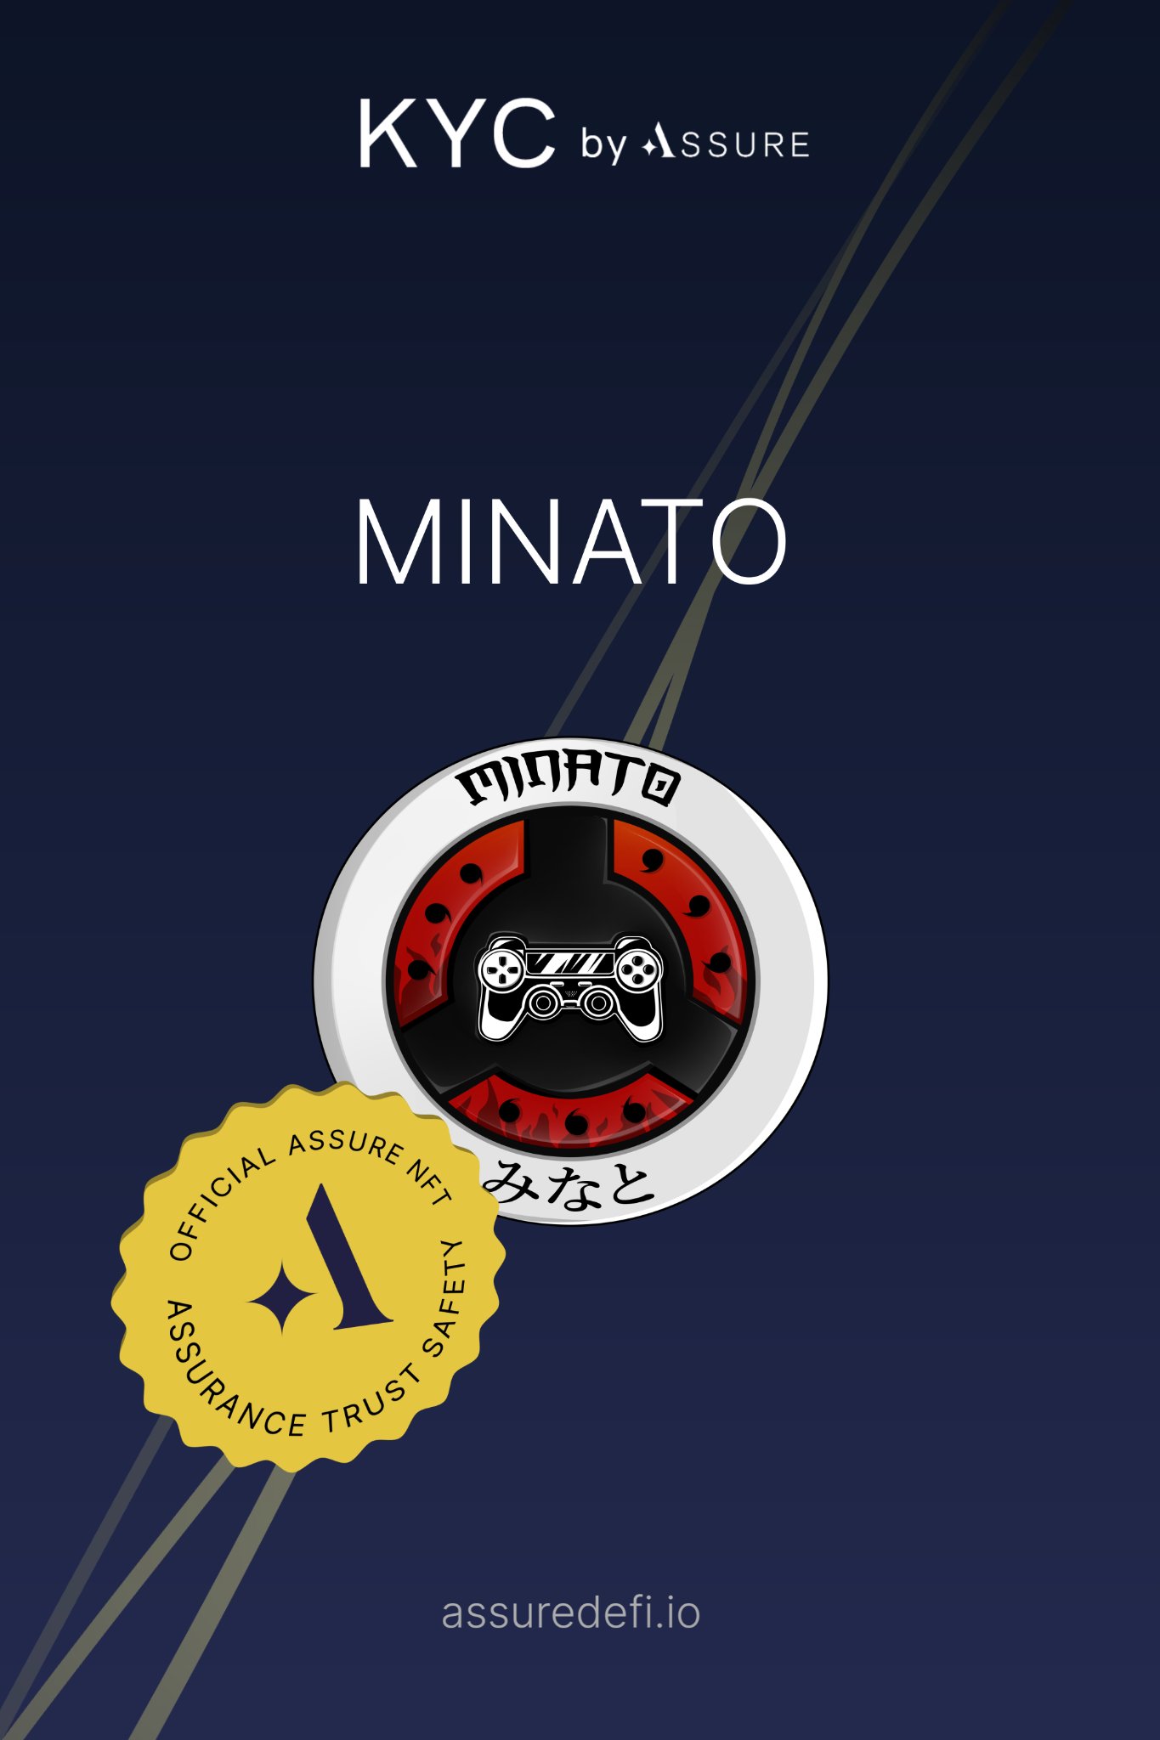

We are committed to holding our leadership accountable for the sake of our investors and we believe this to be a strong positive step for our community.

We aim to build community trust and confidence in the project & are proud to deliver this next step in the evolution of **Minato**!

Assure DeFi offers one the most robust and highly differentiated KYC verification services for projects in the crypto space and this is why we chose them to work with us.

Learn more about Assure’s KYC verification below:

**https://www.assuredefi.io/kyc-nft/**

For more information about Assure DeFi, our KYC verification provider, visit the following links:

𝐋𝐢𝐧𝐤𝐬

💻 [Website](https://assuredefi.io/)

𓅃 [Twitter](https://twitter.com/AssureDefi)

⇝ [Telegram](https://t.me/assuredefi)

⇝ [Medium](https://medium.com/@AssureDefi)